HANU Training Management System

Use-Case-Realization Specification: Upload Announcement (Administrator)

Version <1.0>

*[Note: The following template is provided for use with the Rational Unified Process. Text enclosed in square brackets and displayed in blue italics (style=InfoBlue) is included to provide guidance to the author and should be deleted before publishing the document. A paragraph entered following this style will automatically be set to normal (style=Body Text).]*

*[To customize automatic fields in Microsoft Word (which display a gray background when selected), select File>Properties and replace the Title, Subject and Company fields with the appropriate information for this document. After closing the dialog, automatic fields may be updated throughout the document by selecting Edit>Select All (or Ctrl-A) and pressing F9, or simply click on the field and press F9. This must be done separately for Headers and Footers. Alt-F9 will toggle between displaying the field names and the field contents. See Word help for more information on working with fields.]*

Revision History

| **Date** | **Version** | **Description** | **Author** |
| --- | --- | --- | --- |
| December 5, 2021 | 1.0 | Draft | Lai Hanh Van |
| December 7,2021 | 1.0 | Final | Lai Hanh Van |
|  |  |  |  |
|  |  |  |  |

Table of Contents

1. Introduction 2

1.1 Purpose 2

1.2 Scope 2

1.3 Definitions, Acronyms, and Abbreviations 2

1.4 References 2

1.5 Overview 2

2. Flow of Events—Design 2

3. Derived Requirements 2

Use-Case-Realization Specification: Upload Announcement (Administrator)

# Introduction

*[The introduction of the* ***Use-Case Realization Specification*** *provides an overview of the entire document. It includes the purpose, scope, definitions, acronyms, abbreviations, references, and overview of this* ***Use-Case Realization Specification****.]*

## Purpose

*[Specify the purpose of this* ***Use-Case Realization Specification****]*

This Use-case Realization Specification provides an overview of how the Upload Announcement (Upload Post) use-case is realized within the design model in terms of collaborating objects.

## Scope

*[A brief description of the scope of this* ***Use-Case Realization Specification****; what Use Case model(s) it is associated with, and anything else that is affected or influenced by this document.]*

This document is strictly associated with the Upload Announcement (Upload Post) Use-Case, within the HANU’s EDMS.

## Definitions, Acronyms, and Abbreviations

*[This subsection provides the definitions of all terms, acronyms, and abbreviations required to properly interpret the* ***Use-Case Realization Specification****.  This information may be provided by reference to the project’s Glossary.]*

User – a person who uses the system, can be a student or teacher.

Administrator - a person who is responsible for the activities in the system.

HANU – Hanoi University

EDMS – Educational Management System

## References

*[This subsection provides a complete list of all documents referenced elsewhere in the* ***Use-Case Realization Specification****. Identify each document by title, report number (if applicable), date, and publishing organization. Specify the sources from which the references can be obtained. This information may be provided by reference to an appendix or to another document.]*

[1] ***Use-Case Specification: Upload Announcement,*** Lai Hanh Van, December 07, 2021, HANU Training Management System.

## Overview

*[This subsection describes what the rest of the* ***Use-Case Realization Specification*** *contains and explains how the document is organized.]*

In the following section, this document consists of the realization summary of the event flows that were described in the use-case specifications, specifically in terms of collaborating objects. This is followed by one or more class diagrams and sequence diagrams which demonstrate the event flow realization in further detail. Finally, requirements that are not or have not been considered in the design model will be mentioned, provided that there are any.

# Flow of Events—Design

*[A textual description of how the use case is realized in terms of collaborating objects. Its main purpose is to summarize the diagrams connected to the use case and to explain how they are related.]*

There are four types of objects in this use-case realization: PostView, PostController, Post, and PostData, which is a data access class. The sequence diagram shows the order in which class operations are called. There is a class diagram that shows the structure of each of the above-mentioned classes, their relationships, and the type hierarchies in which they participate. There are no subtasks in the flow.

## Sequence diagram

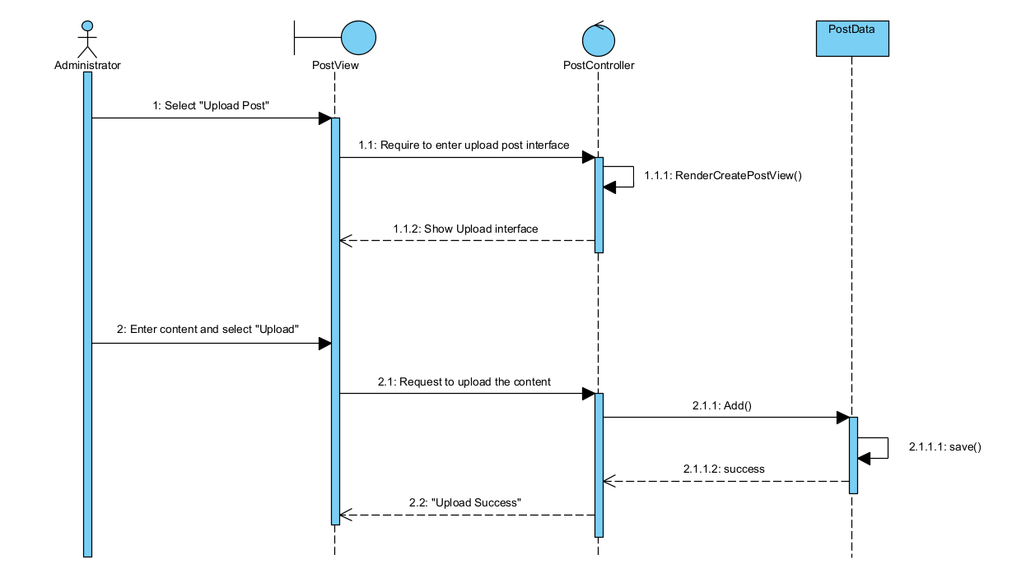

## Class diagram

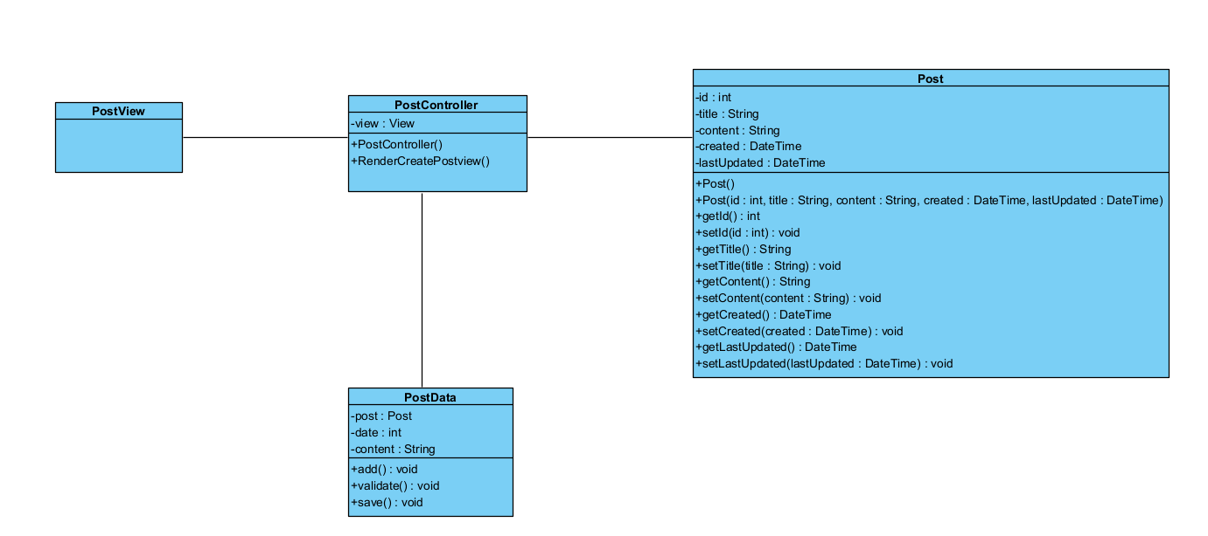

# Derived Requirements

*[A textual description that collects all requirements, such as non-functional requirements, on the use-case realizations not considered in the design model, but that need to be taken care of during implementation.]*.

There are no derived requirements.